Title: Team formation and composition in nascent enterprises

TUTOR: Paola Giuri
DURATA: 24 month
SSD: SECS-P/08 – ECONOMIA E GESTIONE D’IMPRESASEDE DELLA RICERCA: DIPARTIMENTO DI SCIENZE AZIENDALI – sede di Rimini
BUDGET a disposizione del ricercatore post doc per partecipazione a conferenze internazionali: 2000 Euro
PROGETTO DI RICERCA DI RIFERIMENTO: “Nascent entrepreneurship and university-industry knowledge transfer”. Membri del team: Francesco Maria Barbini, Marco Corsino, Paola Giuri.

- Scientific relevance of the research
A fundamental topic for explaining the dynamics of nascent entrepreneurship relates to the nature of skills and competences held by founding teams, in the initial phase of team composition and in the subsequent stages of the team formation process.
The characteristics (mostly in terms of homogeneity or diversity) of the entrepreneur’s skills have been widely analyzed by extant literature (Åstebro and Thompson, 2011; Lazear, 2005; Silva, 2007; Stuetzer et al., 2013). Yet, this literature overlooks situations in which nascent firms are being created by more than one founder. In particular, it is important to reflect whether the cofounders of a nascent firm usually share homogeneous competences or are more likely to have diverse academic and professional backgrounds.
The traditional literature mainly proposes that heterogeneity of team members has a positive impact on the performance of entrepreneurial ventures and is thus based on the assumption that individuals select themselves by searching for heterogeneous members.
However, evidence on this assumption is mixed. Foo et al. (2005) observed that the diversity of a task related characteristics such as educational level of founding team members has a positive impact on the external evaluation of the business idea, while the diversity of a non-task characteristics, i.e. employment status, has a negative effect. The hypothesis of a positive relation between diversity of educational background and performance is also not supported. Foo et al. (2006) further explore the characteristics of team diversity and effectiveness and found that educational diversity is positively related to the perception of team viability, but it is not related to members’ satisfaction, even in socially integrated teams. In a subsequent paper Foo (2011) does not find support to the positive relation between task diversity and member-rated effectiveness of teams and finds only partial support for the positive impact of non-task diversity on team effectiveness. Similarly, Amason et al. (2006) does not confirm the hypothesis of positive relation between diversity of top management team characteristics and new venture performances. Vogel et al. (2014) observed different results in an experimental study, in which participants to the experiment had to take decisions of providing external capital to founding teams with different level and type of diversity. In their study both task and non-task team diversity are positively related to the probability of obtaining early-stage funding.
To sum up, these contributions investigated different types of diversity of team members with varied outcomes. The relation between heterogeneity of founding teams and performance is in some cases positive, in others small or non significant, or results are inconclusive (see also Bell et al., 2011; Bowers et al. 2000; Henneke and Luthje, 2007).
To better understand the role of heterogeneity in teams, other works investigate the factors affecting team compositions (Ruef et al., 2003), and how team heterogeneity evolves over time (Kaiser and Muller, 2015). A starting point is that founding team members in nascent start-ups may initially self-select themselves because they share social contexts, or similar backgrounds and competences, enhancing common languages and trust. Ruef et al. (2003) analyzed five different mechanisms of composition of founding teams and found that homophily of individuals, that is social similarity in ascribed characteristics like age, race or gender, and the presence of prior network ties are more important than functionality, that is similarity in achieved characteristics like education, occupational competencies, income.
In their empirical study Kaiser and Muller (2015) show that heterogeneous teams are more likely the outcome of a dynamic process in which individuals are initially more homogeneous especially in non-task characteristics like age. Over time, as other workforce members are added, the heterogeneity of the workforce increases.
The above two articles indicate that in the initial stages of entrepreneurial processes social similarity mainly characterize team homogeneity, mainly in demographic characteristics like age or parental relations, or deriving from sharing common social contexts or network ties.
A recent survey by Bolzani et al. (2019) reviews several works on the dynamics of team formation and highlight important avenues for future research in the areas of interactions between social processes (friendship, parental relations, culture) and professional characteristics.

In a recent research conducted by the team of this project, we provided a first contribution to this topic, by investigating to what extent university has a role in shaping entrepreneurial teams by creating a favorable social context for aggregating people and sharing ideas (Barbini et al. 2019).
Our research introduced an important novelty in the literature on the role of the university as an informal mechanism spurring student entrepreneurship. To account for the diversity of education, previous studies mainly measured the level and discipline of university education of the team members. The empirical analysis has been conducted either by investigating student entrepreneurship in a single university (e.g. Foo et al. 2005, 2006; Foo, 2011), without variability of the social context, or in larger samples of entrepreneurial teams composed by members graduated in different universities. In these cases, the heterogeneity of the social context was not considered (e.g. Henneke and Luthje, 2007; Kaiser and Muller, 2015).
We were able to identify the proximity of the social context, which is represented by the attendance of team members to programs in the same or different disciplines of the local university, as compared to cases of team members graduated in different universities or non-graduated.
We found that proximity among students is more likely to produce homophily in teams, which are more likely to be composed by people from the same university and specialized in the same discipline.
As suggested by Ruef et al. (2003), founding members tend to share social ties. Therefore, in the absence of specific actions or social contexts stimulating heterogeneity in the disciplines of founding teams, it is more likely to observe more homogeneous teams.

- Research Objectives
This project aims to understand and explain the process of formation and composition of entrepreneurial teams in nascent enterprises.
We expand and develop in emerging and novel directions our current research initially focused on a specific social context, i.e. the local university, favoring the emergence of entrepreneurial ideas and the composition of founding teams.
The research activity is articulated according to four fundamental lines: the first two strands of research aim to assess how the co-founders' common academic and/or professional background shapes the initial heterogeneity/homogeneity of the teams. The third strand of research investigates in detail the team-formation process, starting from the initial heterogeneity/homogeneity: it analyzes the social dynamics that led to define the initial team and develops longitudinal observations to understand how and why the founding team changes during the gestation phase of the nascent enterprise. Finally, the fourth strand of research aims to assess whether and how the team heterogeneity/homogeneity have an impact on the success of gestational activities.

Research objective 1: Assessing the role of the academic background on choices related to the aggregation of cofounders in nascent enterprises.
In a previous study, the research team has investigated the informal mechanisms of knowledge transfer (KT) from a local university (the University of Bologna) to nascent entrepreneurial teams comprising students and recent graduates (SRGs) participating in a business plan competition in the Province of Rimini. Findings show that the local university nurtures the formation of ties among students and recent graduates enrolled in the same courses and fosters their endeavor to launch new ventures. In addition, the qualitative analysis has identified relevant and non-traditional mechanisms of KT that are being exploited by nascent entrepreneurs for developing their business ideas in low-medium and high-tech sectors. This research project will integrate and expand these findings in various directions:
- the extension of the analysis to other regional business plan competitions (in particular, Start Cup Emilia Romagna) for investigating similarities and differences in the entrepreneurial teams comprising SRGs.
- the extension of the analysis to older graduates, in order to understand if the academic background can play a role in the long term, as suggested by Kacperczyk (2013). This extension would also allow understanding the interplay between academic background and professional background.
- the focalization on the characteristics of SRGs from the University of Bologna, with a greater level of analysis on their academic careers, their degree programs, their participation in learning activities related to entrepreneurship.
- the implementation of a quantitative analysis to test the formal and informal mechanisms of KT identified through the qualitative analysis in the previous study.
The research activity will be performed through an econometric analysis of data related to the academic career resulting from the CVs of students and recent and older graduates participating in the business plan competitions.

Research objective 2: Assessing the relevance of work-related experience on the team composition of nascent enterprises.
This research activity is complementary to the first one and is aimed to understand whether the founding teams composed of non-graduates or older graduates show homogeneity linked to the professional experience of the cofounders. The underlying hypothesis to be tested is that co-workers and workers belonging to the same professional family are likely to coalesce to launch a new venture, and how the formation process in this case is driven by decision-making processes that are different from a rational planning of needed skills. For example D’hont et al. (2016) studied the interaction of friendship and professional linkages in the formation of entrepreneurial teams. Furthermore, data on the work experience and previous startup and management experience of nascent entrepreneurs would allow assessing the relevance of this pre-entry knowledge about the competitive market and its dynamics for the definition of the business idea and its actual implementation (Shane, 2000; Dencker et al., 2009).
This strand of research will be performed through an econometric analysis of data related to all the work experiences and the startup experiences resulting from the CVs of non-graduates and older graduates participating in the business plan competitions.

Research objective 3: Understanding the social processes that shape the aggregation of cofounders, with particular reference to the drivers related to common academic or work background, and foster the entry and exit of cofounders during the gestation phase of the nascent startup.
This research activity aims to shed light on the social processes connected with the initial aggregation and the possible modifications of the founding teams in the gestational phase of the nascent enterprise. It therefore implies a longitudinal analysis of the aggregation choices of the founding teams. In addition to understanding the formal and informal mechanisms through which the university and the work context favor the aggregation of cofounders, this research line will allow highlighting the role of social processes (Ruef et al., 2003) and that of the processes aimed at enhancing the functional diversity of skills (Boeker and Wiltbank, 2005) that may play a role in the choices related to the composition of the founding teams (Davidsson and Honig, 2003).
This line of research will be conducted through case studies, interviews and surveys submitted to a selected sample of participants in business plan competition. In addition, it will be conducted a longitudinal analysis of the composition of teams participating in more than one edition of a business plan competition and/or participating in more than one business plan competition (e.g. NINI, StartUp Day, Start Cup).

Research objective 4: Assessing the impact of the founding team heterogeneity/homogeneity on the success of the new venture.
This line of research intends to evaluate the effect of the team's composition choices, considering also changes in the co-founders' team during the gestational phase, on the performance of the nascent enterprise. This effect is not clear in the literature: in some cases it is positive, in others small or non-significant, or results are inconclusive (Amason et al., 2006; Bell et al., 2011; Bowers et al., 2000; Henneke and Luthje, 2007; Foo, 2011; Foo et al., 2005). The performance is declined not in economic-financial terms, but focusing on the outcome, i.e. the actual foundation of the new firm. Alternative performance variables will be considered as robustness checks, such as external recognition by evaluation committees, survival of the new venture, etc. Data on academic background, pre-entry knowledge, and management and startup experience analyzed for the research objectives 1 and 2 will also allow assessing the impact of different sources of knowledge on the performance of the gestation process of the new firm (Shane, 2000; Dencker et al., 2009).

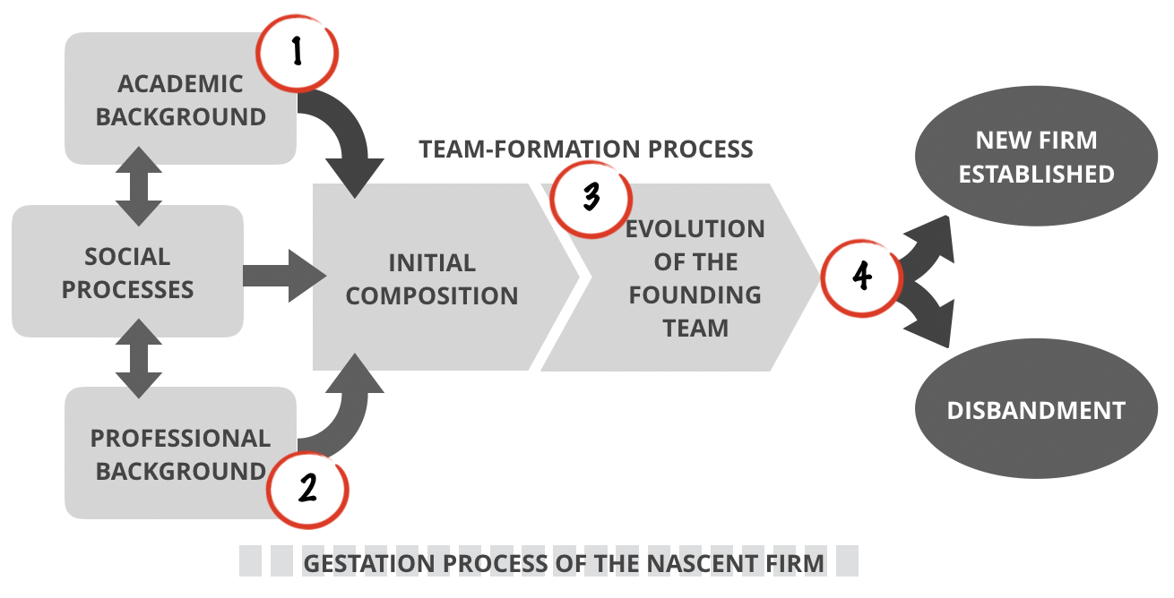

- Methodology
Throughout the research project we will adopt a mixed-method approach that bridges quantitative and qualitative methods.

“Random matching” approach generated through simulations
To analyse the way in which the academic and the professional background of individuals influence the composition of teams, we draw on a methodology used by Ellison and Glaeser (1997) to analyse geographic industry concentration and adopted by Kaiser and Muller (2015) to study the composition of new venture teams.
According to this approach, we compare the degree of heterogeneity computed for the actually observed teams in the sample with a benchmark, namely, a “random matching” generated through simulations, comprising a random assembly of start up teams among the participants we observe in our data. Such a comparison enables us to establish if “the observed degree of heterogeneity is statistically significantly different from the degree of heterogeneity in a situation where teams are randomly assembled. Thus, our benchmark is a situation where founders do not systematically look for teammates” (Kaiser and Muller, 2015: 793).

Thematic analysis methods for qualitative data and surveys
To explore how and why (Yin, 1994) social ties spurred by university attendance and professional experience shape the process of team formation through informal and even unplanned or non-deliberate activities, we plan to implement thematic analysis of interviews and a survey based on the results of the qualitative analysis.
We already designed an exploratory research approach based on interviews with founders of entrepreneurial teams and developed an interview protocol composed of semi-structured questions. Questions have been sketched with the goal of understanding complex phenomena, such as knowledge transfer processes, the origin of the business idea, the process of forming the founding team, the perceptions of any direct and indirect impact the university had on the entrepreneurial process, the relevance of the knowledge acquired at the university, the overall assessment of the relevance of knowledge acquired at the university, suggestions about additional support the university might provide.
We will apply the thematic analysis method (Merton, 1975; Boyatzis, 1988) to analyse qualitative data (Braun & Clarke, 2006) and identify codes and relevant recurrent themes.
In a first exploratory analysis we applied the thematic analysis to interviews conducted to 11 team founders. In this project we aim to expand the qualitative analysis to a larger and more heterogeneous set of interviewees.
The interview protocol and the themes resulting from the thematic analysis will be the basis for developing a survey directed to the members of entrepreneurial teams. The survey will aim to collect quantitative data on informal mechanisms for knowledge transfer and social processes shaping homogeneous or heterogeneous teams. We will also ask information about the outcome of business idea, especially relevant for abandoned ideas or failed venture, for which data are more difficult to be collected. We will check non-response biases particularly in these cases.

Econometric estimations
We will resort to econometric techniques to investigate the processes that shape the aggregation of cofounders across different projects and/or business plan competitions, and to study the relationship between team composition and the outcome of the entrepreneurial ventures. For example, exploiting repeated observations for individuals who submitted multiple projects along time, we will use panel data econometrics to control for unobserved heterogeneity at the individual level which might eventually bear meaningful consequences on the selection and turnover of team members. Likewise, we will estimate a set of econometric models using multiple indicators of firm performance so as to account for the multiple dimensions of this construct that earlier research has emphasized (Miller et al., 2013).

- Sources of data
- Nuove Idee Nuove Imprese (NINI): full availability of data about proponents’ CVs and entrepreneurial ideas submitted. NINI is a business plan competition organized by an association comprising local Chambers of Commerce, Industrial associations, bank foundations, and Universities located in the Province of Rimini and the Republic of San Marino. Every year, people interested in establishing new firms are invited to submit their synthetic business ideas to NINI. Since its foundation in 2002, NINI has gathered more than 350 business plans Overall, more than 1.200 people has participated in the competition. For individuals and projects we have detailed information about their education and professional experience, in addition to personal characteristics like age, location, role in the team, etc.

- Start Cup Emilia-Romagna (SCER): data about business plans and participants. Founded in 2000, SCER has become the business plan competition of the research centers and the universities of the Emilia-Romagna region. Individual startuppers and teams proposing innovative business ideas can participate in the competition. The business idea must demonstrate a formal connection between the idea itself or its technology content and a national or international University or research center.

- StartUp Day (SUD): data about business ideas and participants in the event. SUD is an event organized by the University of Bologna allow its students with a business idea to present it to investors and startuppers and to get in touch with other students with potentially useful skills.

- Survey on team composition and gestation activities: an on-line survey has been carried out that involves individuals submitting an entrepreneurial idea in the most recent edition of the NINI business plan competition (i.e., 2018 and 2019). Participants were surveyd in two stages: 1) at the moment in which they file their application for the contest; 2) when they complete the first round of courses meant to offer the basics about launching a new ventures. In the first occasion we are interested to collect data on the motivations to take part in the competition, whether a team as been already created and who is part of such a group; which gestational activities the proponents have already undertaken to turn the entrepreneurial project into a an actual firm. In the second occasion, we collect data about the training activities that participants attended and about changes in the composition of the entrepreneurial team.
The survey, as described above, will be replicated for the next editions of NINI, SCER, and SUD.

- Survey on formal and informal mechanisms of KT from university to nascent entrepreneurs and outcome of the business ideas: a survey, based on the results of a previous qualitative research, is planned for all university students and recent and old graduates participating in NINI, SCER, and SUD.

- Interviews and case studies: a selected sample of founders will be interviewed to enhance the understanding of the social processes underlying the initial composition of teams. Furthermore, meaningful cases of new firm creation will be investigated, with particular reference to their top-management team formation process.

- Databases: official data on new firm creation will be extracted from the databases of the Chambers of Commerce, AIDA, and other available repositories. Additional data about the career development and the startup experience of graduates will be extracted by AlmaLaurea.

- Data from the web: data about the professional experience of founders will also be extracted from their LinkedIn pages; data about the evolution of new firms will be found in their web sites.

- Research plan
The project is articulated in seven work packages (WPs). WP1, WP2 and WP7 act as support work packages, while WP3, WP4, WP5, and WP6 will carry out the primary activities directly connected with the achievement of the research goals.
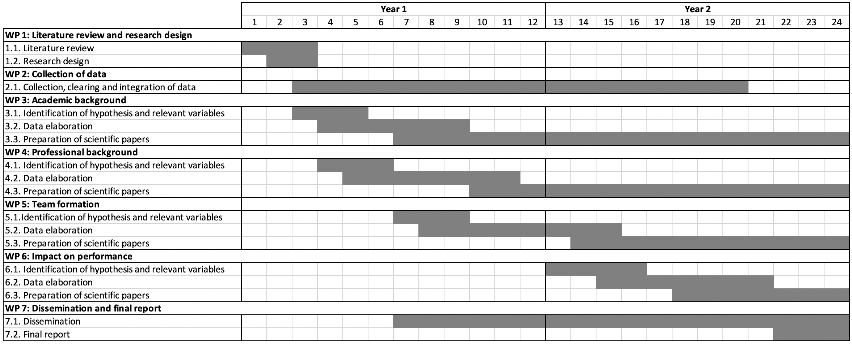

WP1 concerns the review of the literature and the detailed design of the research. Its results are the input for WP3, WP4, WP5 and WP6.
WP2 deals with all the activities related to the collection (through the various methods identified, e.g. surveys, databases, interviews), cleaning and integration of data. It carries out activities as defined and pulled by WP3, WP4, WP5 and WP6.
WP3 coordinates all the research activities related to the attainment of the research objective 1 (academic background) and runs in parallel with WP4 (professional background). WP5 deals with the research objective 3 (understanding team-formation process) and starts in the second half of the first year, when first elaborations of data from WP3 and WP4 become available.
WP6 covers the activities related with the research objective 4 (impact on performance) and starts on the second year, basing on the evidence from WP3, WP4 and WP5.
WP7 concerns the dissemination of results in the academic community and the elaboration of the final report.

- Expected results and impact on knowledge advancement
The results of the project will contribute to the theoretical discussion and will provide valuable implications for policies and managerial practices.

We expect the following theoretical contributions:
- Extension of the literature on the process of team formation in nascent enterprises. Actually, the limited number of studies on nascent enterprises in general, and on the composition of their teams of cofounders in particular, does not allow to have a clear understanding of the dynamics of top management team aggregation and change during the critical process of gestation of the new enterprise. This project will analyze rich data on the profiles and behavior of nascent entrepreneurs and it will shed light on these dynamics, which are usually subtle and difficult to observe, thus allowing their explanation, especially as far as the interaction of social processes and professional/educational characteristics are concerned.
- Detailed explanation of the most relevant formal and informal mechanisms of knowledge transfer between university and nascent entrepreneurs. This result will be particularly relevant since extant literature focus almost exclusively on formal mechanisms, overlooking the role played by the informal ones. In this way, the results of the project may contribute to a more complete understanding of the whole range of knowledge channels through which the university nurtures student entrepreneurship. Furthermore, the analysis of older graduates allows understanding the long-term impact of academic knowledge and social ties.
- Extension of the literature on the role of professional background on the choices related to team composition of nascent enterprises. This contribution will integrate existing literature, which is mostly focused on the composition of top-management teams in established enterprises.
- Integration of the literature on the relationship between team composition and performance of the nascent enterprise. Extant literature does not highlight robust evidence. The richness of data available to the project should allow finding more robust relationships between these variables.

The main expected outcomes in terms of policy and management practices are:
- The identification of public and private policies aimed at stimulating entrepreneurship, in particular student entrepreneurship. This may imply a more consistent design of university programs and initiatives for stimulating entrepreneurship. Furthermore, local public and private institutions may implement more coherent policies for supporting the entrepreneurship by exploiting useful knowledge from university.
- The opportunity to design enabling environments and initiatives for supporting the socialization of subjects with similar/different knowledge and experience in order to stimulate the development of successful nascent enterprises. In particular, actions could be set up for increasing the awareness of the importance of heterogeneous competences in entrepreneurial teams and a variety of interventions could be designed for exposing potential founders to heterogeneous social contexts.

- Profile of the post-doc and expected scientific results
Profile of the post-doc fellow:
- PhD in Management, Economics, Statistics or related fields;
- Research experience on economics and management, with a preference for research in entrepreneurship and related areas;
- Competence in data management and econometric analysis.

The expected training outcomes for the post-doc are the following:
- Learning and development of advanced econometric techniques on large and small datasets.
- Training in survey design, implementation and quantitative analysis of survey data
- Training in methods and use of advanced software for qualitative analysis
- Close interactions with members of the research team, including faculty, PhD students and post-doc researchers.
- Development of abilities to publish in International journals by co-authoring papers with the tutor and other members of the research team.
- Opportunity to present research outcomes at international workshops and conferences.

Expected scientific results:
- 2 papers presented in primary international conferences in management and entrepreneurship;
- 1 R&R in top management journals (ABS 4*) or 2 R&R in leading management journals (ABS 3 or 4);
- A final report detailing the results of the research projects, a synthesis of the activities performed, and a plan of activities to be completed or integrated.

- References
Amason, A., Shrader, R.C., & Thompson, G.H. (2006), Newness and novelty: relating top management team composition to new venture performance. Journal of Business Venturing, 21, 125-148.
Åstebro, T., & Thompson, P. (2011). Entrepreneurs: jacks of all trades or hobos? Research Policy, 40(5), 637-649.
Barbini, F.M., Corsino, M., Giuri, P., (2019), How do universities shape founding teams? Social proximity and informal mechanisms of knowledge transfer in student entrepreneurship. Journal of Technology Transfer, accepted for publication.
Bell, S.T., Villado, A.J., Lukasik, M.A., Belau, L., & Briggs, A.L. (2011). Getting specific about demographic diversity variable and team performance relationships: A meta-analysis. Journal of Management, 37(3), 709-743.
Boeker, W., & Wiltbank, R. (2005). New venture evolution and managerial capabilities. Organization Science, 16(2), 123-133.
Bolzani, D., Fini, R., Napolitano, S., & Toschi L. (2019), Entrepreneurial Teams: An Input-Process-Outcome Framework. Foundations and Trends in Entrepreneurship, 15(2), 56–258.
Bowers, C.A., Pharmer, J.A., & Salas, E. (2000). When member homogeneity is needed in work teams: A meta-analysis. Small Group Research, 31(3), 305-326.
Boyatzis, R.E. (1998). Transforming qualitative information: Thematic analysis and code development. Thousand Oaks, CA: Sage.
Braun, V., & Clarke, V. (2006). Using thematic analysis in psychology. Qualitative Research in Psychology, 3(2), 77–101.
Davidsson, P., & Honig, B. (2003). The role of social and human capital among nascent entrepreneurs. Journal of Business Venturing, 18(3), 301-331.
Dencker, J.C., Gruber, M., & Shah, S.K. (2009). Pre-entry knowledge, learning, and the survival of new firms. Organization Science, 20(3), 516-537.
D’hont, L., R. Doern, and J. B. Delgado García (2016). The role of friendship in the formation and development of entrepreneurial teams and ventures. Journal of Small Business and Enterprise Development. 23(2): 528–561.
Ellison, G., & Glaeser, E.L. (1997). Geographic concentration in US manufacturing industries: a dartboard approach. Journal of Political Economy, 105(5), 889-927.
Foo, M. (2011). Teams developing business ideas: How member characteristics and conflict affect member-rated team effectiveness. Small Business Economics, 36, 33–46.
Foo, M., Wong, P., & Ong, A. (2005). Do others think you have a viable business idea? Team diversity and judges’ evaluation of ideas in a business plan competition. Journal of Business Venturing, 20, 385–402.
Fremeth A.R., Holburn G.L.F., & Richter B.K. (2016) Bridging Qualitative and Quantitative Methods in Organizational Research: Applications of Synthetic Control Methodology in the U.S. Automobile Industry. Organization Science, 27(2): 462-482.
Henneke, D., & Lüthje, C. (2007). Interdisciplinary heterogeneity as a catalyst for product innovativeness of entrepreneurial teams. Creativity and Innovation Management, 16(2), 121-132.
Kacperczyk, A.J. (2013). Social influence and entrepreneurship: The effect of university peers on entrepreneurial entry. Organization Science, 24(3), 664-683.
Kaiser, U., & Müller, B. (2015). Skill heterogeneity in startups and its development over time. Small Business Economics, 45(4), 787-804
Lazear, E.P. (2005). Entrepreneurship. Journal of Labor Economics, 23, 649-680.
Merton, R. K. (1975). Thematic analysis in science: Notes on Holton’s concept. Science, 188(4186), 335–338.
Miller C.C., Washburn N.T., & Glick W.H. (2013). The Myth of Firm Performance. Organization Science, 24(3): 948-964.
Ruef, M., Aldrich, H.E., & Carter, N.M. (2003), The structure of founding teams: Homophily, strong ties, and isolation among U.S. entrepreneurs. American Sociological Review, 68(2), 195-222.
Shane, S. (2000). Prior knowledge and the discovery of entrepreneurial opportunities. Organization Science, 11(4), 448-469.
Silva, O. (2007). The jack of all trades entrepreneur. Innate talent or acquired skills. Economic Letters, 97(2), 118-123.
Stuetzer, M., Obschon, M., & Schmitt-Rodermund, E. (2013). Balanced skills among nascent entrepreneurs, Small Business Economics, 41(1), 93-114.
Vogel, R., Puhan, T.X., Shehu, E., Kliger, D., & Beese, H. (2014). Funding decisions and entrepreneurial team diversity: A field study. Journal of Economic Behavior & Organization, 107, 595-613.
Yin, R.K. (1994). Case study research: design and methods. Newbury Park, CA: Sage.

